**ĐỀ SỐ 1**

**ĐỀ KHẢO SÁT CHẤT LƯỢNG HỌC SINH GIỎI**

**Môn: TIẾNG ANH LỚP 8**

**SECTION A: LISTENING (3,0P)**

**Part 1.** You will hear five short conversations. You will hear each conversations twice. There is one question for each conversations. For question 1-5, put the tick ✓ under the right answer. (1,0p)

**Example**: How many people were at the meeting?

3

30

13

**√**

A B C

1. Which is the woman’s friend?

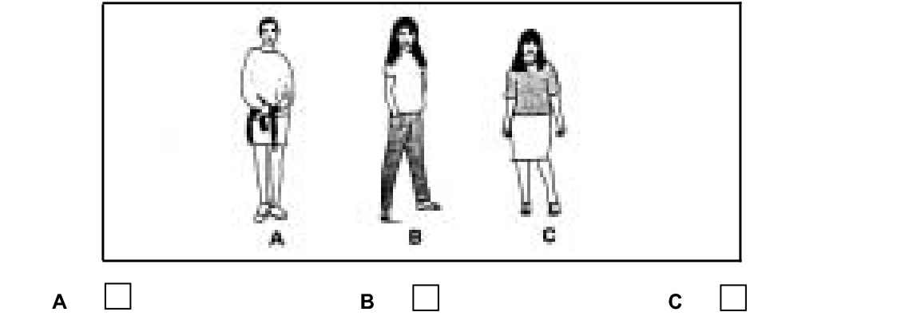

2. What animal has Sue got?

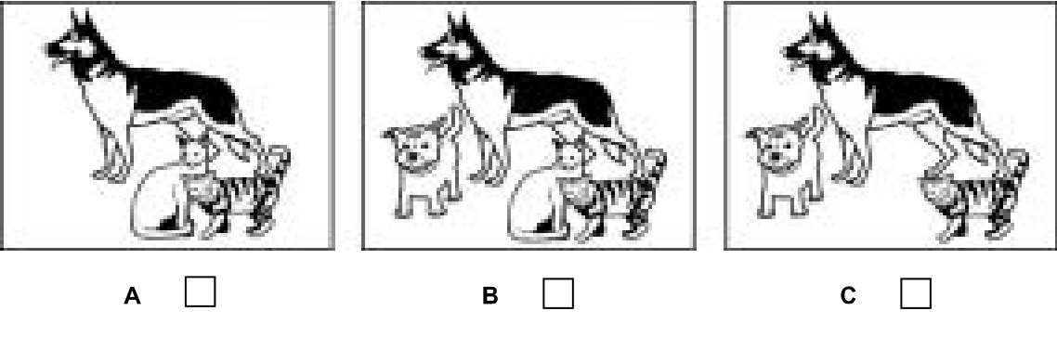

3. What time will they go to the cinema?

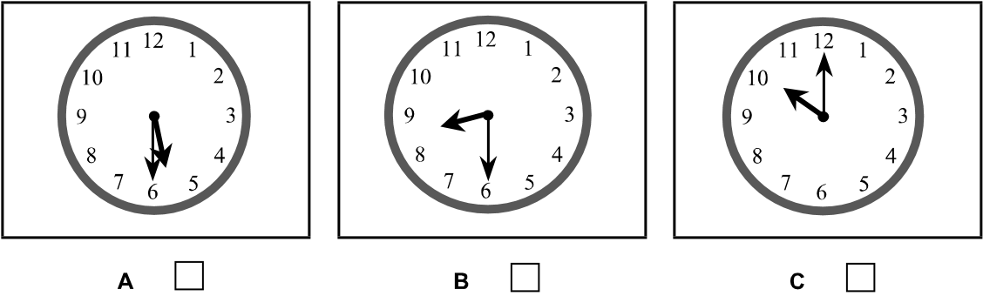

4. What is Joe going to do at the weekend?

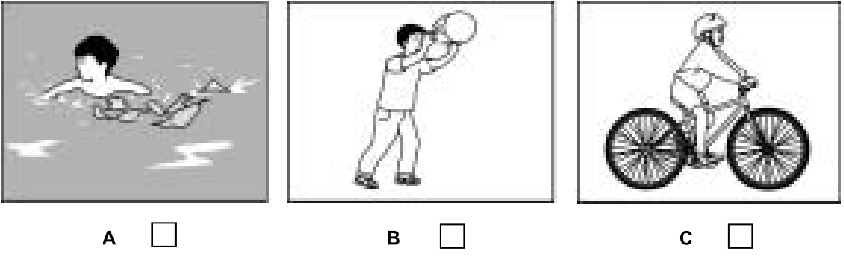

5. Which man is the English teacher?

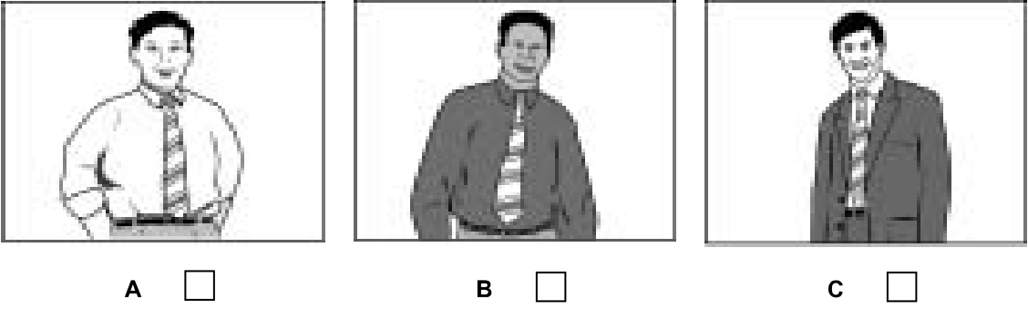

**Part 2.** Listen to Steve telling Olga about his birthday presents.Which presents did each person give him?For questions 6-10, write a letter (A-H) next to each person.You will hear the conversation twice. (1,0p)

|  |  |  |  |
| --- | --- | --- | --- |
| **People** | | **Presents** | |
| 6 | Harry | A | book |
| 7 | Linda | B | camera |
| 8 | Thomas | C | chocolates |
| 9 | Victoria | D | jacket |
| 10 | James | E | pen |
|  |  | F | socks |
|  |  | G | sweater |
|  |  | H | video |

**Your answer:**

**Example: 0. Mary- D**

|  |  |  |  |  |
| --- | --- | --- | --- | --- |
| 6 | 7 | 8 | 9 | 10 |

**Part 3.** Listen to Paul asking about a club for children.For questions 11-15, tick (🗸) A, B or C**.** You will hear the conversation twice. (1,0p)

**Example:**

0. The Children’s Fun Club has offices in…….

A. the U.S 🞏 B. India 🞏 C. London 🗹

11. The club tries to help children with their………..

A. studies 🞏 B. sports 🞏 C. painting 🞏

12. This month, the children will get a …………

A. video 🞏 B. magazine 🞏 C. pen 🞏

13. The club has a competition every………

A. week🞏 B. month 🞏 C. year 🞏

14. The club is for children under………..

A. 10 🞏 B. 13🞏 C. 16 🞏

15. The club costs……….

A. £ 3 a year 🞏 B. 5 £ a year 🞏 C. £ 12 a year 🞏

**Part 3.** Listen to Paul asking about a club for children.For questions 11-15, tick (🗸) A, B or C**.** You will hear the conversation twice. (1,0p)

**Example:**

0. The Children’s Fun Club has offices in…….

A. the U.S 🞏 B. India 🞏 C. London 🗹

11. The club tries to help children with their………..

A. studies 🞏 B. sports 🞏 C. painting 🞏

12. This month, the children will get a …………

A. video 🞏 B. magazine 🞏 C. pen 🞏

13. The club has a competition every………

A. week🞏 B. month 🞏 C. year 🞏

14. The club is for children under………..

A. 10 🞏 B. 13🞏 C. 16 🞏

15. The club costs……….

A. £ 3 a year 🞏 B. 5 £ a year 🞏 C. £ 12 a year 🞏

**SECTION B. PHONETICS (1,0P)**

**I.** **Pick out the word whose underlined part is differently pronounced in each line. (0,5p)**

1. A. stay B. lake C. climate D. vacation

2. A. summer B. include C. instruction D. compulsory

3. A. cooked B. asked C. naked D. impressed

4. A. says B. plays C. days D. raise

5. A. height B. neighbor C. weigh D. eight

|  |  |  |  |  |
| --- | --- | --- | --- | --- |
| 1 | 2 | 3 | 4 | 5 |

**II. Pick out the word that has the stress differently from that of the other words. (0,5p)**

1. A. density B. negative C. organize D. enormous

2. A. appear B. addition C. begin D. special

3. A. technique B. planet C. engine D. fearful

4. A. busy B. dirty C. address D. modern

5. A. traditional B. telescopic C. petroleum D. technology

|  |  |  |  |  |
| --- | --- | --- | --- | --- |
| 1 | 2 | 3 | 4 | 5 |

**SECTION C. VOCABULARY AND GRAMMAR (8,0P)**

**I. Choose the word, phrase or expression which best completes each sentence. (2,0p)**

1. I think he will join us, ______________?

A. doesn’t he  B. won’t he  C. will he  D. do I

2. You meet a friend at the air port on arrival and you might say: “__________Da Lat”

A. Welcome to B. Be welcome to C. Welcome in D. Well come to

3. We must begin testing the instrument, no matter _________ difficult it is.

A. however B. how C. whatever D. what

4. Quite soon, the world is going to ...................... energy resources.

A. run out of B. get into C. keep up with D. come up again

5. John: “I didn’t pass my driving test.” - Anna: “_________!”

A. Better luck next time B. Congratulations

C. So poor D. That was nice of them

6. ___________every part of the world has experienced an earthquake in recent years.

A. Most B. Each C. Almost D. Nearby

7. Lan is wearing a___________dress.

A. beautiful red new B. new beautiful red

C. red beautiful new D. beautiful new red

8. We have written to each other ………………..last Christmas.

A. for B. since C. until D. before

9. They decided to go………………it was raining heavily.

A. and B. but C. though D. since

10. He is a very .......................person. I really like talking with him.

A. interested B. interesting C. bored D. boring

11. He …………..in his son

A. Takes part B . is proud C. takes pride D. takes out

12. Nga had difficulties in bringing the heavy box, and Mai, her friend, offered to help.

- Mai : “Need a hand with your heavy box, Nga ?”

- Nga : “.....................”

A. I don’t need. B. Not at all.

C. That’s very kind of you . D. No, thanks.

13. This is Mr Brown, ............. invention has helped hundreds of deaf people.

A. who B. whom C. whose D. that

14. She wondered.....................her only son was then.

A. where B. if C. whether D. what

15. He took his seat quietly,............ .

A. in order that not to disturb their conversation B. so as to disturb their conversation

C. in order not disturb their conversation D. so as not to disturb their conversation

16. Neither the students nor the teacher ________ come.

A. has B have C. is D. are

17. It costs about fifty dollars to have a tooth ________.

A. filling B. to fill C. filled D. being filled

18. You should pay attention ________ what the teacher said.

A. of B. with C. in D. to

19. Sue was _______ in the accident; meanwhile, her sister has only minor injuries.

A. seriously ill B. badly injure C. seriously hurt D. bad

20. Stop that nonsense,...............?

A. don’t you B. do you C will you D. aren’t you

**II. Give the correct tense/form of the verbs in brackets to complete these sentences. (1,0p)**

A friend of mine, Judith Nelso (1.presently work) in the international sales division at an electronic firm. She (2. just return) from a trip to Japan. She (3.ask) (4. go) to Japan because she can speak Japanese. When she (5. be) a business student at Boston University, she (6. study) Japanese for four years. She (7. never/ have) the opportunity to use her Japanese until she (8. go) to Tokyo last year. While she was there, she (9. speak) Japanese every day and (10. enjoy) every minute of it.

***Your answer***

|  |  |  |  |  |
| --- | --- | --- | --- | --- |
| 1 | 2 | 3 | 4 | 5 |
| 6 | 7 | 8 | 9 | 10 |

**III. Give the correct form of the words in brackets. (2,0p)**

|  |  |
| --- | --- |
| Emma Harte, in Barbara Taylor Bradford's novel, was a poor **lonely**  girl who became the (1)....................owner of an international chain of stores. Like the woman she write about, Ms Bradford is beautiful and (2)............. She left school at sixteen and became a (3)............... After twenty-three years of this work, she made the (4).......... to start writing novels. She is now one of the most (5)..........-paid novelists in the world. Was Emma Harte's story based on Ms Bradford's own (6)........... successful life? "I'm afraid not," she said with(7)....... "My life has been quite different from Emma Harte's. She was (8).................to be born into a poor family. I came from a middle-class home and I'm (9) ...........married to a rich American film producer. The only thing I share with my heroine is her (10).................................to work hard." | LONE  1-WEALTH  2- AMBITION  3- JOURNAL  4- DECIDE  5- HIGH  6- CREDIBLE  7- AMUSE  8- LUCK  9 - HAPPY  10- ABLE |

***Your answer***

|  |  |  |  |  |
| --- | --- | --- | --- | --- |
| 1 | 2 | 3 | 4 | 5 |
| 6 | 7 | 8 | 9 | 10 |

**IV. Identify the underlined word or phrase (A, B, C or D) in each sentence below that must be changed in order for the sentence to be correct. (1,0p)**

1. Even though studying hard, he failed his exam last year.

A B C D

2. The pollution of the sea can be the result of careless or dumping of waste.

A B C D

3. If today is Sunday, we would have a lot of fun at the camping.

A B C D

4. She apologized for being many rude to me.

A B C D

5. Tom has not completed the assignment yet, and Maria hasn’t, neither.

A B C D

***Your answer***

|  |  |  |  |  |
| --- | --- | --- | --- | --- |
| 1 | 2 | 3 | 4 | 5 |
| 6 | 7 | 8 | 9 | 10 |

**V. Complete each of the sentences with one of the phrasal verbs given below. Make any changes if necessary. (2,0p)**

**1. look after 2. slow down3*.* look down on 4. make out 5.call in**

**6.draw up 7. try on8. ring off 9. put aside 10. sit up 11*.* settle on**

1. Can you ***look after*** our dog while we’re away on holiday?
2. His condition is worse than before. I think we should _____________________ a doctor.
3. A red car has just _____________________ in front of our house. Are we expecting anyone?
4. Don’t _____________________ Peter just because he’s not as good at the job as you are.
5. Could you _____________________, please. I don’t like driving so fast on country roads.
6. The name on the cheque is wrong. The cheque is ____________________ to your brother, not to you.
7. I wonder if this dress fits. I’ll ________________it__________ and see.
8. I’m sorry, but I’ll have to _____________________ now. Someone has just come into the office.
9. Don’t spend the money you won. Why don’t you ___________it________ to buy what you really want?
10. There was an excellent film on television late last night. We ______to watch it.
11. We couldn’t decide whether to book a holiday in Spain or Italy. We finally ______ in Spain.

.

**SECTION D. READING COMPREHENSION (4,0P)**

**I. Read the following passage then choose the most suitable answer from the four options marked A, B, C or D to fill in each numbered blank. Identify your answer by writing the corresponding letter A, B, C or D on your answer sheet. ( 1,0p)**

**The power of nature**

The wind controls our planet’s weather and climate, but how much do we understand about this complex force, which can kill and spread fear?

On the night of 15th October 1987, the south of England was struck by the (1)...... winds it had known for over two hundred years. (2)...... of over 130km/h blew through the region. Nineteen people were killed, £1.5 billion-worth of (3)...... was caused and 19 million trees were (4) ..........in just a few hours.

Although people thought of this as a hurricane, the winds of 1987 were only (5) .......storm force. They are far better known than the much more serious storms of 25th January 1990, when most of Britain was hit by daytime winds of up to 173 km/h. On this (6)....... 47 people were killed, even though, unlike in 1987, the weather forecasters issued accurate(7)........... .(8) ......... weather events such as these are dramatic reminders of the power of the wind. It is one part of the weather that people generally do not (9)........ a second thought to, but across the world the wind (10)........... a crucial role in people’s lives.

1. A. heaviest B. fastest C. strongest D. quickest

2. A. Blows B. Hits C . Clouds D. Gusts

3. A. hurt B. injury C. destruction D. damage

4. A. blown down B. cut down C. knocked down D. blown up

5. A. powerful B. severe C. serious D. dangerous

6. A. occasion B. event C. accident D. incident

7. A. threats B. warnings C. news D. signs

8. A. Extreme B. Excessive C. Extravagant D. Exaggerated

9. A. have B. make C. put D. give

10. A. has B. makes C. plays D. does

**Your answer:**

|  |  |  |  |  |
| --- | --- | --- | --- | --- |
| 1 | 2 | 3 | 4 | 5 |
| 6 | 7 | 8 | 9 | 10 |

**II. Read the text below and think of the word which best fits each space. Use only ONE word in each space. (2,0p)**

Speech is one of the most important (1) ________ of communicating. It consists of far more than just making noises. To talk and also to be (2) ________ by other people, we have to speak a language, that is, we have to use combinations of (3) ________ that everyone agrees stand for particular object or idea. Communication would be impossible if everyone made up their own language.

(4) ________ a language properly is very important. The basic (5) ________ of English is not very large, and only about 2000 words are needed to (6) ________ it quite well. But the more words you know, the more ideas you can (7) ________ and the more precise you can be about their exact meaning.

Words are the (8) ________ thing we use in communicating what we want to say. The (9) ________ we say the words is also important. Our tone of voice can express many motions and (10) ________ whether we are pleased or angry, for instance.

***Your answer***

|  |  |  |  |  |
| --- | --- | --- | --- | --- |
| **1** | **2** | **3** | **4** | **5** |
| **6** | **7** | **8** | **9** | **10** |

**III. Read the following passage and choose the most suitable sentence from the list A - H for each gap from 1 - 5. There are two extra sentences that you do not need to use. Write your answer in the space provided. (0) has been done as an example. ( 1,0p)**

The Sahara’s meager resources are being plundered right to the present day. This is shown most clearly in the dramatic fall in the region’s precious water reserves. The rock is of a type which hinders easy underground storage so the water supply depends on rainfall. (**0**) ***B***. However, the seriousness of the situation goes far beyond mere seasonal changes.

There’s one district where observations go back at least 125 years. Here it is known that wells of the balance beam type were once used in cultivated areas. This way of drawing water is intended for the irrigation of gardens and small plots and works only if there’s water not more than about five metres below the surface.

(**1**) ______. They have all been replaced by wells from which the water has to be raised by draught animals, because it is now 25 metres down. (**2**) ______.

In a classic example of a vicious circle, shortage of water has led to the digging of more wells to save the flocks and birds. As these have been deepened the water supply has been further depleted. (**3**) ______.

The Air region was once regarded as the Switzerland of Africa because of its temperate climate. (**4**) ______. Nowadays, though, there are only a third of the palms which existed there at the turn of the century. The amount of wildlife has shown a proportionate fall. (**5**) ______. This is highly dangerous in a world where the overall population is growing rapidly. We cannot afford to lose fertile land.

**A.**So, too, has the number of human beings who can now survive in the area.

**B.**This being so, it is easy to understand why it varies.

**C.**Today, though, not one well of this type exists.

**D.**This has resulted in soil erosion which then dries out the land still further.

**E.**Here, then, the water level has evidently dropped by 20 metres in little over a century.

**F.**It was criss-crossed by valleys filled with palm trees and was thronged with wildlife.

**G.**Such are conditions in the Sahara Desert in recent times.

***Your answer:***

|  |  |  |  |  |
| --- | --- | --- | --- | --- |
| 1 | 2 | 3 | 4 | 5 |

**SECTION E. WRITING (4,0P)**

**I. Finish each of the following sentences in such a way that it means exactly the same as the sentence printed before it. (1,0p)**

1. Please don't make me annoyed by such silly questions.

-> I’d rather …………………………………………..……….…….........…………….

2. It was careless of you to leave the windows open last night

-> You shouldn’t have …………………………………..……….……….......................………...

3. He learned a lot of things as he traveled far.

-> The…………………………………, the…………………………........................................

4. It takes three hours to drive from Hai phong to Hanoi

-> It is …………………………………………….……..……………...............................…….

5. Though he broke his legs, he tried his best to go to school.

-> In……………………....................................................................………………………………..

**II. Complete the sentences using the words given. Make all the changes and additions if neccessary. (1,0p)**

1. After/ walk/ three hours/ we/ stop/ let/ others/ catch/ up/ us.

-> ..............................................................................................................................................................

2 There/ be/ more/ and/ challenges/ school children today/ early age.

-> .................................................................................................................................................................

3. He/ suggest/ use/ gas/ instead/ burn/ coal/ for/ cook.

-> .................................................................................................................................................................

4. Solar panels/ install / roof/ house/ energy/ sun.

-> ................................................................................................................................................................

5 What form/ communicate/ you / think/used/ most / 2100?

->...................................................................................................................................................................

**III. Nowadays, more and more people like living in the countryside. Use about 150 words to write a paragraph about the advantages of living in the countryside. (2,0p)** ..........................................................................................................................................................................